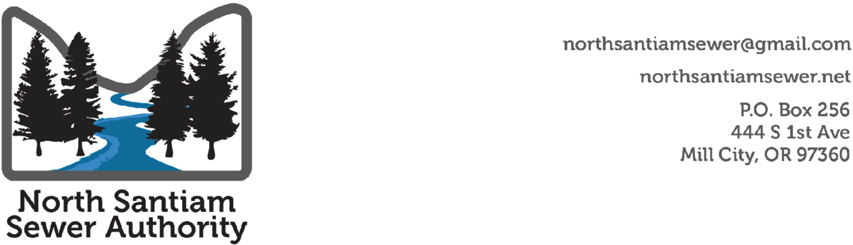

**Board Meeting**

**Summary Notes**

**October 2nd at 6:00 PM**

<https://zoom.us/j/93414748822?pwd=MjJkM3Vyb21YS1BDK2doVEpIZ25uUT09>

Meeting ID: 934 1474 8822

Passcode: 454959

Called to order 6:03 p.m. Adjourn 8:00 p.m.

1. Roll Call and Declarations of Conflicts of Interest

**Present:** Kirsch, Gander, Evans, Zeyen-Hall, Nielsen, Woodward

**Absent:** Morones

**Zoom:**

**Guests:** Mary Camarata, DEQ, Beth Wyrtoski, Regional Solutions Coordinator for Polk-Yamhill- Marion County, Slayden Construction, K & E Excavating, Marion County Public Works, Brian Nicholas Public Works Director and Chris Einmo Project Manager, Peter Olsen, Keller Associates Engineering, Gordon Wilson, FCS consultants

**Announcements**

None

1. **Public Comment**
2. **Action:**
3. September Summary Notes were approved. Gander moved to accept. Ron Seconded. Motion passed unanimously.
4. Treasurer Report: Gander Moved

Zeyen-Hall Second

Approved - unanimous.

1. September 28th Legislative Breakfast Debrief

Ken Woodward created a one-page document with a funding request.

COG legislative committee will write a letter of support for the funding request.

Motion for COG to create scope of work and process to procure an attorney firm to assist with interim operating agreements and related work to prepare to receive sewer system assets.

Motion by Brian Gander. Second by Denny Nielsen. Motion passed unanimously.

1. Slayden Constructors Introduction and Presentation: Jeff Wall, Slayden, Tom Paul, Slayden, K & E Excavating, Kerry Kuenzi
2. Marion County:

* Presented information about the overall process including the outreach pursuant to the submission of the facility plan.
* Presented updated FCS report.

1. Ron Evans introduced his draft operational plan.   The board will discuss the plan in detail at future work sessions.
2. The topic of commercial septic in Gates was tabled for a future meeting.

The topic of staff for NSSA was tabled for a future meeting.

Adjourn 8:02

**Upcoming Events:**

|  |  |  |
| --- | --- | --- |
| **Date** | **Event** | **Location** |
| October 16th, 6-8 pm | NSSA Board Work Session | Mill City |
| November 6th, 6-8 pm | NSSA Board Meeting | TBD |
| November 20th, 6-8 pm | NSSA Board Work Session | TBD |
| December 4th, 6-8 pm | NSSA Board Meeting | TBD |