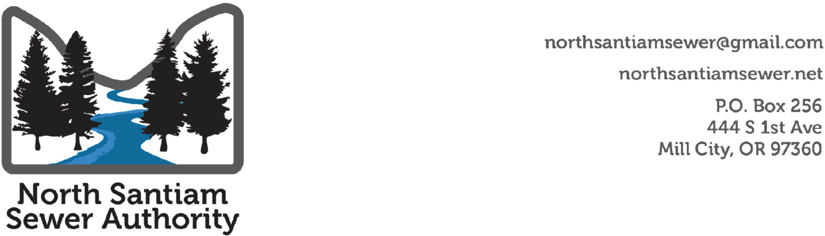

**NSSA Work Session**

**Summary Notes**

**August 24th at 6:00 PM**

<https://zoom.us/j/93414748822?pwd=MjJkM3Vyb21YS1BDK2doVEpIZ25uUT09>

Meeting ID: 934 1474 8822

Passcode: 454959

1. Roll Call and Declarations of Conflicts of Interest

**Present:** Tim Kirsch Mill City; Ken Woodward Detroit; Ron Evans Gates. Brian, Janet Zeyen-Hall, Mill City: Denny Nielsen Gander Gates

**Absent:** Tony Morones Idanha.

**Zoom:**

1. **Announcements**

None

1. **Public Comments**

Members of the Mill City Community who live near one of the test sites expressed concerns about the location of the proposed system and were seeking additional information about the project.

1. **Board Instruction**

The board instructed staff to reach out to local government law groups to form agreements that will allow NSSA to direct cities to apply for grants, loans, and bonds and other authorities needed to operate the system to confirm ownership of assets.

The board discussed the formation of ORS 450 and 451. Brian Gander offered that long-term an entity like a 450 or 451 that could hold all assets would be a good idea.

The group agreed that a joint venture to keep the cities together in an effort to build, operate, and maintain the system for the entire canyon as an interim step was important.

Discussion occurred about how to fund the construction of the upper basin using the benefit of the collaboration.

Tim Kirsch reiterated that he does not want to fund the construction of the system using debt service.

Janet Zeyan-Hall offered that she did not believe the canyon communities would support a separate entity.

Ken Woodward offered that the ORS 190 was selected in the past to ensure continued local control.

1. Adjourn

6:53 pm

**Upcoming Events:**

|  |  |  |
| --- | --- | --- |
| **Date** | **Event** | **Location** |
| September 11th, 6-8 pm | NSSA Board Meeting | TBD |
| September 18th, 6-8 pm | NSSA Board Work Session | TBD |
| October 2nd, 6-8 pm | NSSA Board Meeting | TBD |
| October 16th, 6-8 pm | NSSA Board Work Session | TBD |
| November 6th, 6-8 pm | NSSA Board Meeting | TBD |
| November 20th, 6-8 pm | NSSA Board Work Session | TBD |
| December 4th, 6-8 pm | NSSA Board Meeting | TBD |